2023 Wittry Programming Contest

A couple of notes and hints as you compete in this contest.

* All programs will be compiled and tested using java 11.0.2.
* To score any points, ALL your program must compile with java 11.0.2
* **Points can be earned for completing parts of a program**. That is, it is possible to earn partial credit on all prompts.

Every problem is worth 10 points, except for

* FunctionsGoneWild2023 is worth 16 points

This brings the grand total to 106 possible points.

* Note: problems are listed in alphabetically order with no regard to ease or difficulty of each problem

You will be given a Print out of all 10 prompts and a Flash Drive with three folders. The ‘prompt’s folder contains the prompts both as a word file and as a pdf.

The ‘Team # java files’ Folder contains only the java files and the ‘Working folder’ contains both the java files and the Junit test files. Use the Junit test files to make sure your files compiles.

The ‘Team # java files’ is the folder I will grade at the end. ALL files in the folder must remain in the Folder. In order to have your work graded**, ALL java files MUST compile**. If just one file does not compile, your program will score 0 on Stipulator. Please, only java files should be in the Folder. You may add helper classes and you may add helper method to any of the existing classes.

The ‘Working folder’ has been provided allowing you to work on/modify the java files without jeopardizing you score. I would suggest you work on the files in the ‘Working Folder’, and as you complete each class/java file, replace that the java file in the ‘Team # java files’ Folder.

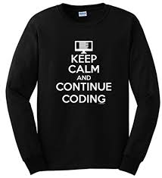At 12 PM, you are to bring me your Flash drive, I will copy the ‘Team # java files’ Folder to my folder where I will grade it with Stipulator.



And lastly – I hope you have a great time problem solving and creating coding, and please spread the word at your school and with friends how much fun you had today!